

**PROJECT REPORT ON SELENIUMPRACTICE TESTING WEBSITE**

**BY**

**PRATIKSHA AGHAV**

**BATCH: EON (2021-5765)**

**Under Guidance of**

**PRIYANKA DESALE**

**(TECHNICAL TRAINER)**

**EDUBRIDGE**

**INTRODUCTION**.

As an important method to ensure quality of Web Applications, web testing attracts more and more attentions in the academic community and industrial world.

The work describes the requirement and constraints of testing a Web Application System for the Passion Tea Company. In the project referred to here, a Selenium Web driver tool used and different platform Such as Chrome, Firefox and Edge used.

This project attempts to do comprehensive testing, such as functional and GUI testing on a website, to ensure that the application is of high quality. It aids in the improvement of website quality and saves time by eliminating the need for manual testing. The main goal of this project is to test the website's functionality.

**SOFTWARE REQUIREMENTS**

* Operating System: Windows 10
* Browser: Latest version of Chrome
* IDE: Eclipse IDE
* Automation Tool: Maven
* Front-end: Java

**To Launch Browser and Get Website:**

//browser launch

System.*setProperty*("webdriver.gecko.driver","C:\\Users\\ASUS\\Downloads\\geckodriver.exe");

WebDriver w = **new** FirefoxDriver();

//get url

w.get("http://www.practiceselenium.com/");

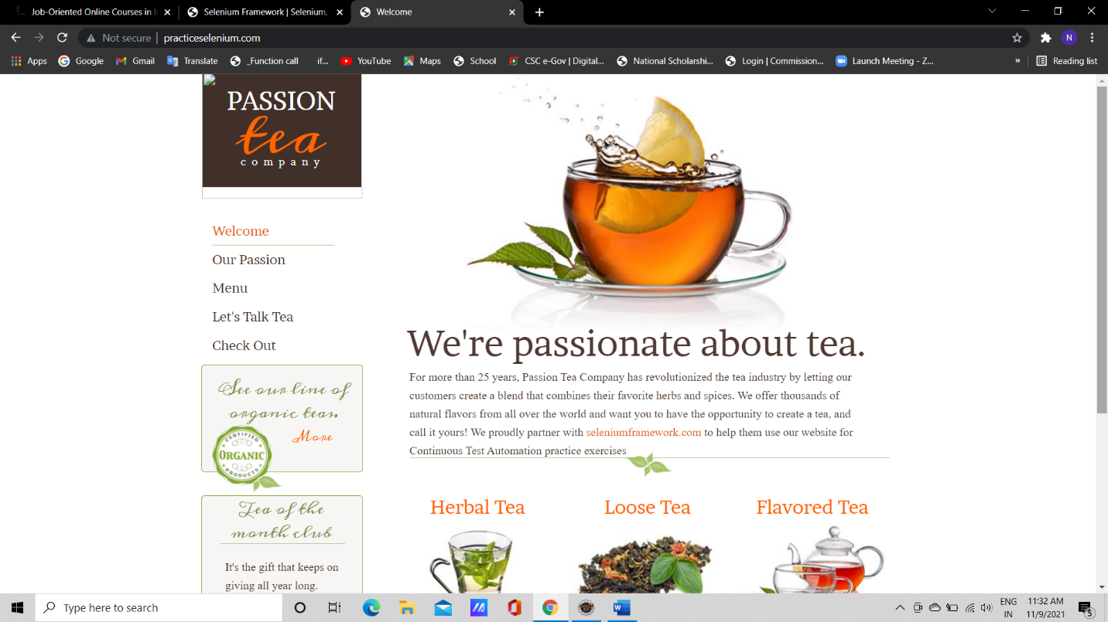

Fig: Output

Loading Issue: Most of the time during the Browser launch and getting URL this site shows so much loading issue.

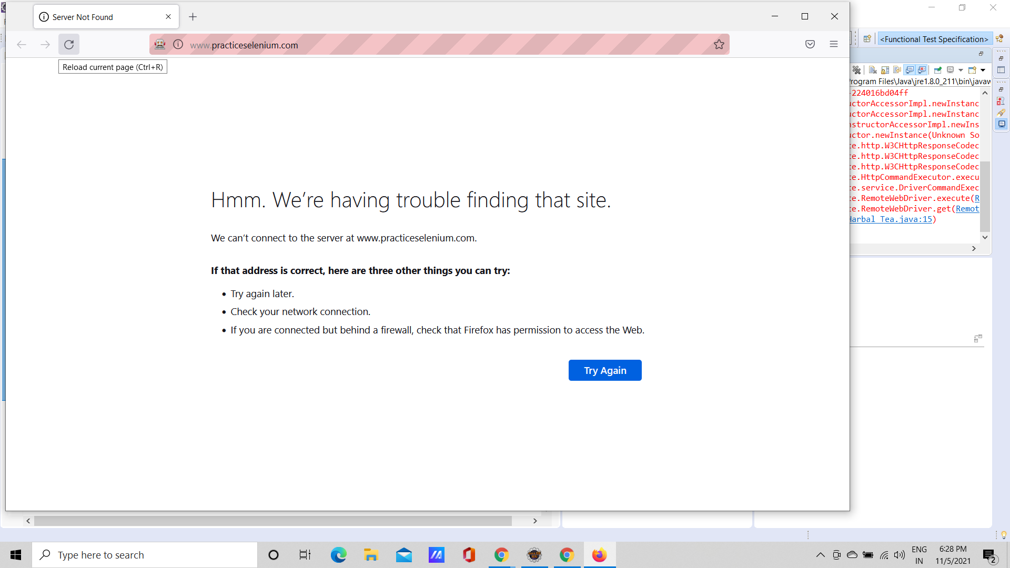

Fig 1 : Defect 1- Loading Issue

**To test Welcome, Our Passion & Menu**

w.findElement(By.*linkText*("Welcome")).click();

w.findElement(By.*linkText*("Our Passion")).click();

w.findElement(By.*linkText*("Menu")).click();

w.findElement(By.*linkText*("Check Out")).click();

w.findElement(By.*id*("email")).sendKeys("ankitachaudhari20@gmail.com");

w.findElement(By.*id*("name")).sendKeys("Ankita");

w.findElement(By.*id*("address")).sendKeys("Sai Nagar");

Select s =**new** Select(w.findElement(By.*id*("card_type")));

s.selectByIndex(2);

w.findElement(By.*id*("card_number")).sendKeys("123654789025") w.findElement(By.*id*("cardholder_name")).sendKeys("SBI"); w.findElement(By.*id*("verification_code")).sendKeys("1234");

w.findElement(By.*xpath*("/html/body/div/div/div[1]/div/div[1]/div/div/form/div/a")).click();//

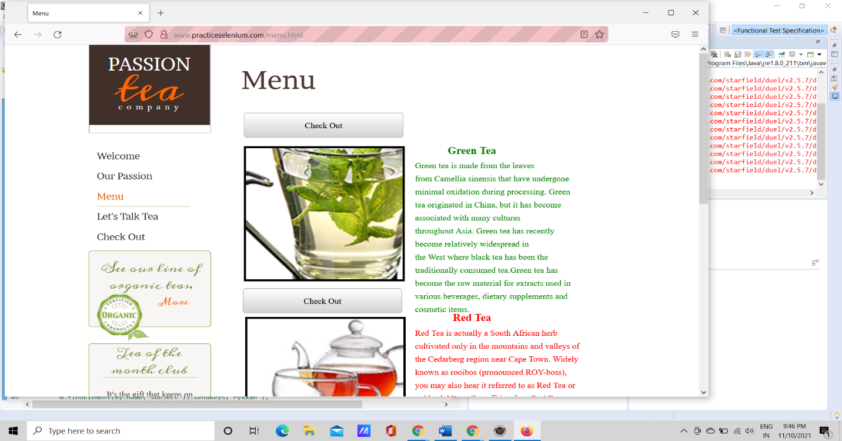

Output : After Executing the Program this Window will open

**To Test More and Let’s Talk Tea**

// click on more

w.findElement(By.*linkText*("More")).click();

w.findElement(By.*linkText*("More")).click();

// lets talk tea

w.findElement(By.*linkText*("Let's Talk Tea")).click();

//w.findElement(By.linkText("View larger map")).click(); // maps take much time to load

w.findElement(By.*name*("name")).sendKeys("xyz");

w.findElement(By.*name*("email")).sendKeys("ankita@gmail.com");

w.findElement(By.*name*("subject")).sendKeys("ryxxxh"); w.findElement(By.*name*("message")).sendKeys("I love this tea");

w.findElement(By.*className*("form-submit")).click(); //defect

w.findElement(By.*linkText*("Welcome")).click();

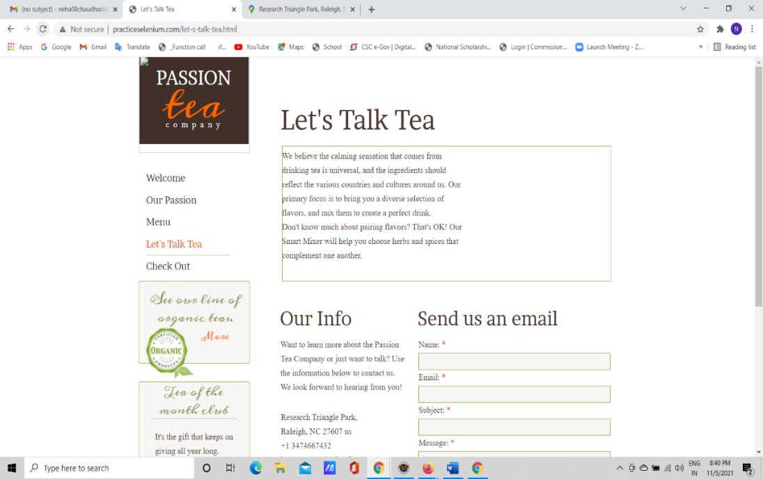

Here the Map Should be Visible Which takes so much time to load

Button is Not Working: Submit Button

This button is not functioning/ non clickable

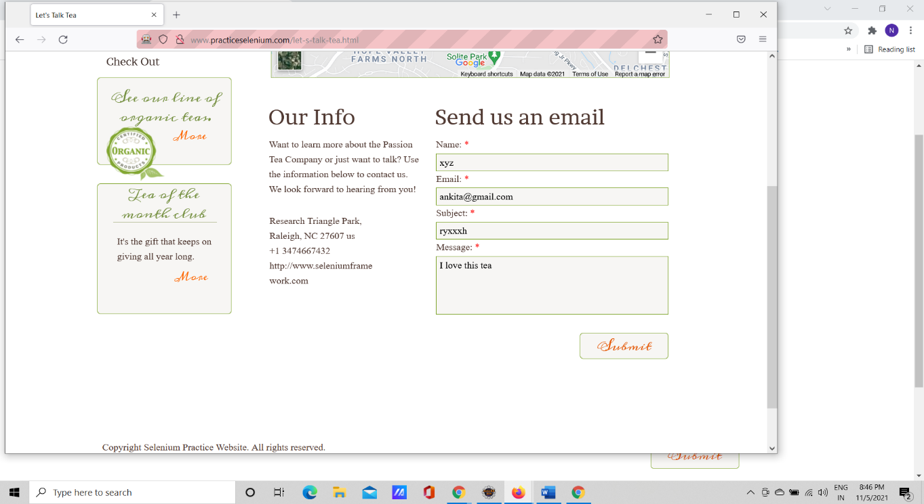

Non – clickable

Should be clicked/ redirected to Next page

**To test Checkout**

w.findElement(By.*linkText*("Check Out")).click();

w.findElement(By.*id*("email")).sendKeys("ankitachaudhari20@gmail.com");

w.findElement(By.*id*("name")).sendKeys("Ankita");

w.findElement(By.*id*("address")).sendKeys("Sai Nagar");

Select s =**new** Select(w.findElement(By.*id*("card_type")));

s.selectByIndex(2);

w.findElement(By.*id*("card_number")).sendKeys("123654789029”);

w.findElement(By.*id*("cardholder_name")).sendKeys("SBI");

w.findElement(By.*id*("verification_code")).sendKeys("1234");

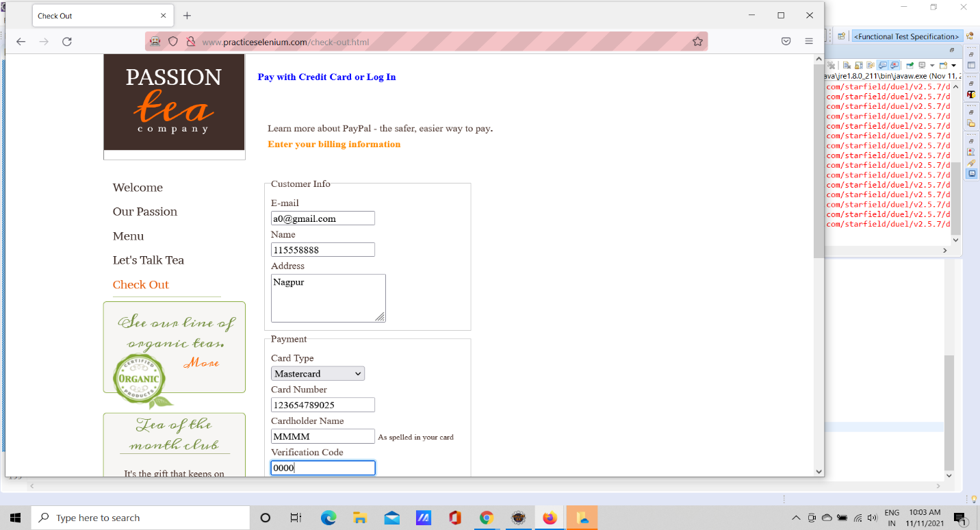

**To Test Menu**

w.findElement(By.*linkText*("See Collection")).click();

w.findElement(By.*linkText*("Check Out")).click();

w.findElement(By.*id*("email")).sendKeys("a0@gmail.com");

w.findElement(By.*id*("name")).sendKeys("115558888");

w.findElement(By.*id*("address")).sendKeys("Nagpur");

Select s5 =**new** Select(w.findElement(By.*id*("card_type")));

s5.selectByIndex(2);

w.findElement(By.*id*("card_number")).sendKeys("123654789025");

w.findElement(By.*id*("cardholder_name")).sendKeys("MMMM");

w.findElement(By.*id*("verification_code")).sendKeys("0000");

w.findElement(By.*xpath*("/html/body/div/div/div[1]/div/div[1]/div/div/form/div/a")).click();//

**To Test Selenium Framework**

w.findElement(By.*linkText*("Welcome")).click();

w.findElement(By.*linkText*("seleniumframework.com")).click();

w.findElement(By.*linkText*("HOME")).clear();

w.findElement(By.*linkText*("TUTORIALS")).clear();

w.findElement(By.*linkText*("PRACTICE")).clear();

w.findElement(By.*linkText*("SELENIUM")).clear();

w.findElement(By.*linkText*("CUCUMBER")).clear();

w.findElement(By.*linkText*("PYTHON")).clear();

//w.findElement(By.linkText("FORUMS")).click(); this locator are not working.

//w.findElement(By.xpath("//*[@id=\"main-nav\"]/li[7]/a")).click();

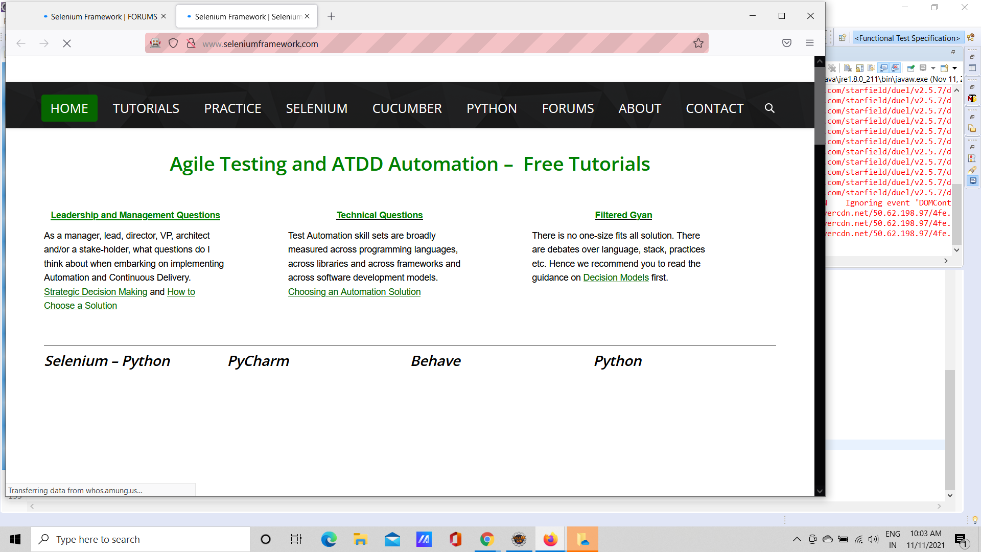

FIG: Output

**To Test Forums**

w.get("http://www.seleniumframework.com/forums/");

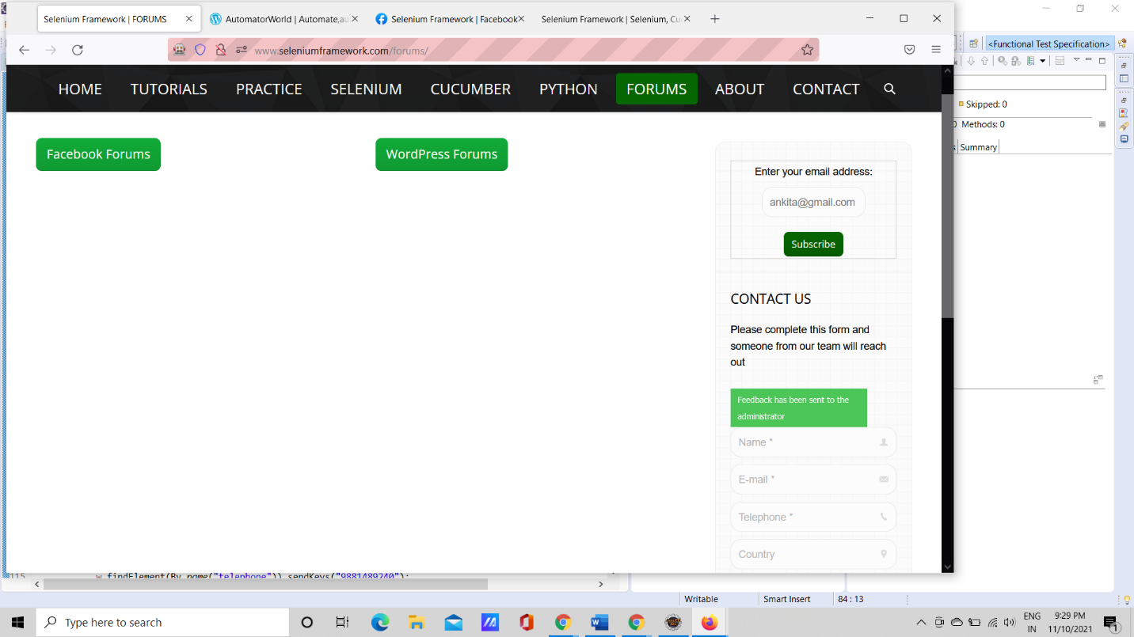

FIG: Output

**To Test facebook Forum**

w.findElement(By.*linkText*("Facebook Forums")).click();

w.navigate().to("http://www.seleniumframework.com/forums/");

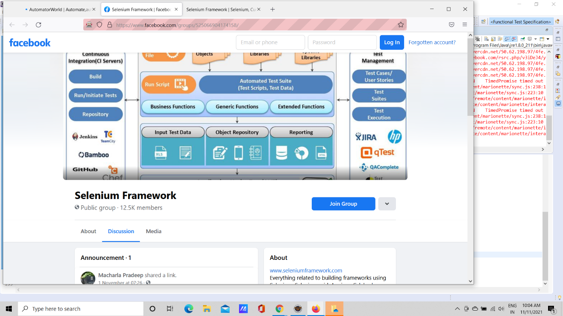

Fig:Output

**To Test Wordpress Forum**

w.findElement(By.*linkText*("WordPress Forums")).click();

//w.navigate().to("http://www.seleniumframework.com/forums/");

w.findElement(By.*name*("email")).sendKeys("ankita@gmail.com");

w.findElement(By.*xpath*("//*[@id=\"text-11\"]/div/form/input[3]")).click();

Thread.*sleep*(3000);

Set<String> window =w.getWindowHandles();

Iterator<String> it=window.iterator();

String parent_w = it.next();//0th index

String child_w =it.next();//1st index

w.switchTo().window(child_w);

w.switchTo().window(parent_w);

w.findElement(By.*name*("name")).sendKeys("Ankita Chaudhari");

//w.findElement(By.name("email")).sendKeys("ankita");//shows error correct

w.findElement(By.*xpath*("//*[@id=\"presscore-contact-form-widget-3\"]/form/div/span[2]/input")).sendKeys("neha@yahoo.com");

//w.findElement(By.name("telephone")).sendKeys("");//s error correct

w.findElement(By.*name*("telephone")).sendKeys("9881489240");

w.findElement(By.*name*("country")).sendKeys("India");

w.findElement(By.*name*("company")).sendKeys("CG");

w.findElement(By.*name*("message")).sendKeys("I like this page ");

w.findElement(By.*linkText*("Submit")).click();

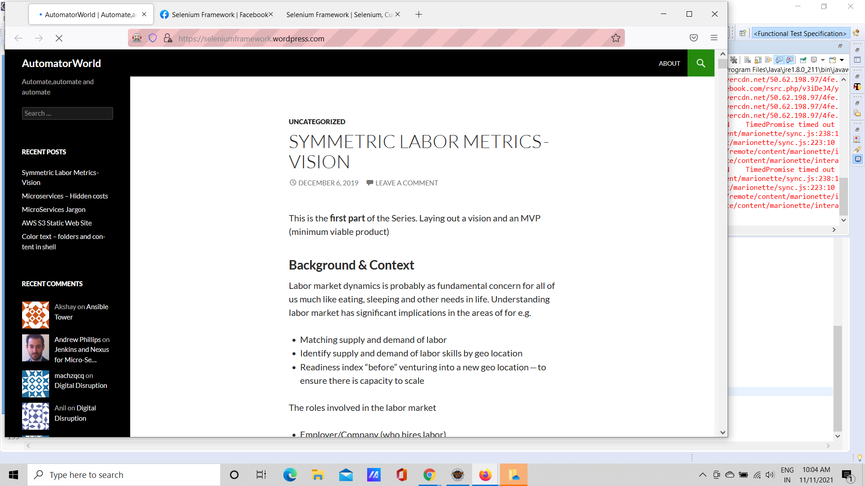

Fig: Output

**To Test Wordpress Forum with Invalid Data**

//Invalid data

w.findElement(By.linkText("seleniumframework.com")).click();

w.findElement(By.linkText("HOME")).click();

w.findElement(By.linkText("TUTORIALS")).click();

w.findElement(By.linkText("PRACTICE")).click();

w.findElement(By.linkText("SELENIUM")).click();

w.findElement(By.linkText("CUCUMBER")).click();

w.findElement(By.linkText("PYTHON")).click();

w.findElement(By.linkText("FORUMS")).click();

w.findElement(By.linkText("Facebook Forums")).click();

w.navigate().back();

w.findElement(By.linkText("WordPress Forums")).click();

w.navigate().back();

w.findElement(By.name("email")).sendKeys("ankita@gmail");

w.findElement(By.xpath("//*[@id=\"text-11\"]/div/form/input[3]")).click();

w.findElement(By.name("name")).sendKeys("@@12536");

w.findElement(By.name("email")).sendKeys("12536nn@gmail");

w.findElement(By.name("telephone")).sendKeys("bhyuhuhuhhu");

w.findElement(By.name("country")).sendKeys("ChaudhariLayout");

w.findElement(By.name("company")).sendKeys("12536aa");

w.findElement(By.name("message")).sendKeys("12354mkjgygyg ");

//w.findElement(By.linkText("Submit")).click();

w.findElement(By.linkText("clear")).click();*/

**To Test See Collection for Loose Tea**

w.get("http://www.practiceselenium.com");

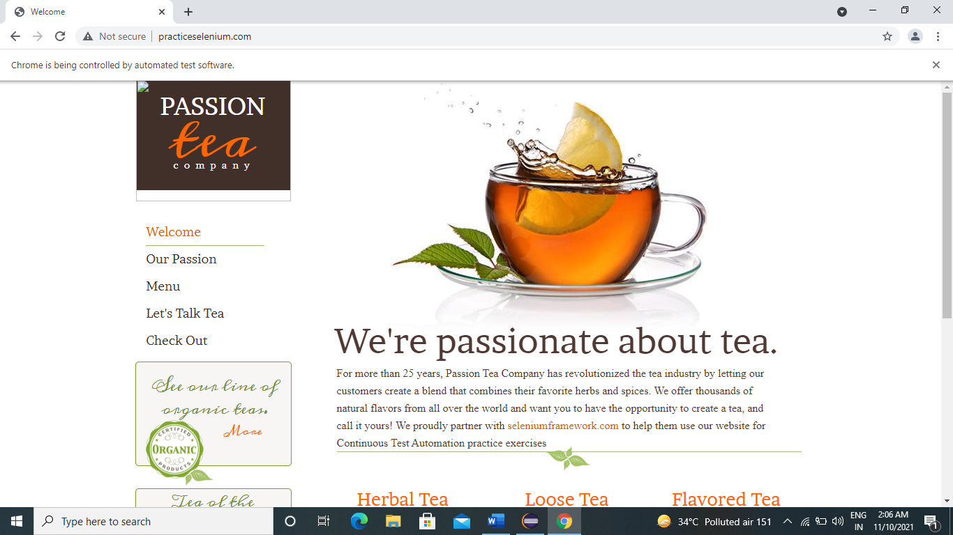

w.findElement(By.linkText("See Collection")).click();

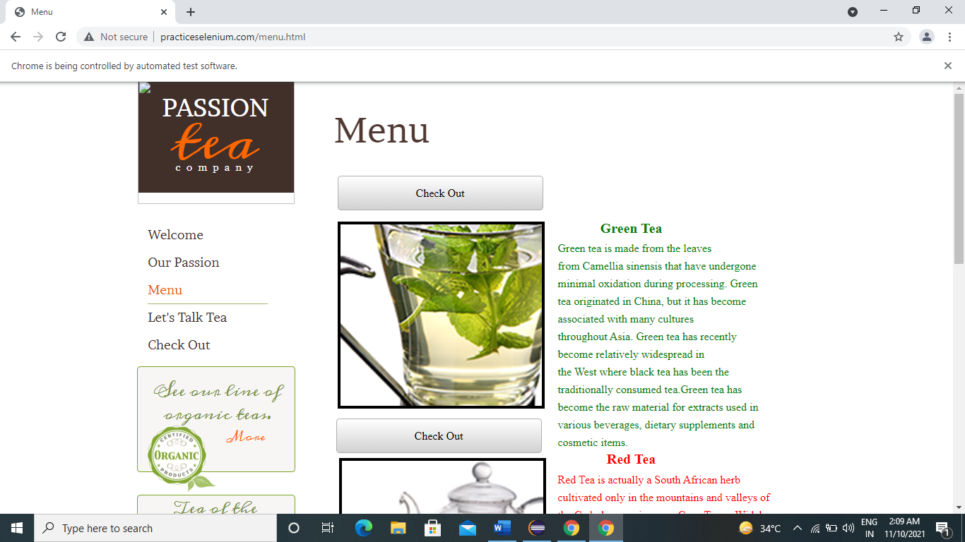

**To Test See Check Out for Loose Tea**

w.findElement(By.*linkText*("Check Out")).click();

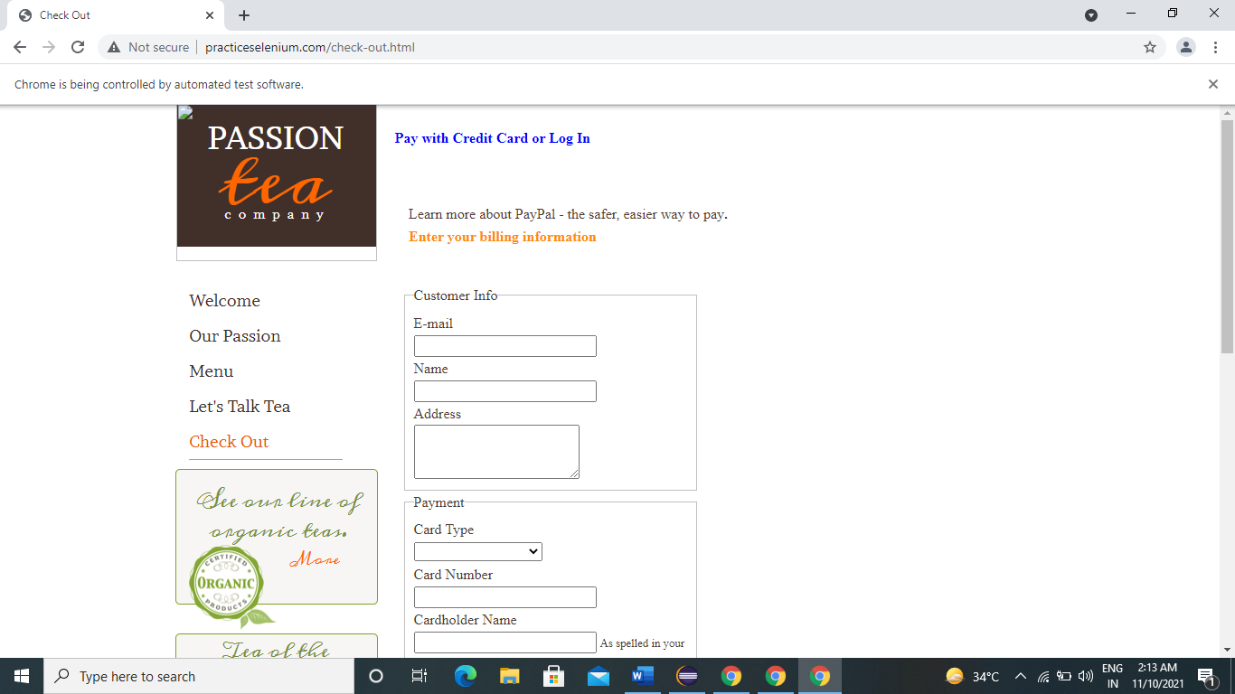

w.findElement(By.*id*("email")).sendKeys(" [nitishaaghav123@gmail.com](mailto:nitishaaghav123@gmail.com)");

w.findElement(By.*id*("name")).sendKeys("Nitisha Aghav");

w.findElement(By.*id*("address")).sendKeys("Sudama Bhel Pune");

Select s=**new** Select(w.findElement(By.*id*("card_type")));

s.selectByVisibleText("Mastercard");

w.findElement(By.*id*("card_number")).sendKeys("222-222-2222");

w.findElement(By.*id*("cardholder_name")).sendKeys("Nitisha Aghav");

w.findElement(By.*id*("verification_code")).sendKeys("122223");

w.findElement(By.*xpath*("//*[@id=\"wsb-element-00000000-0000-0000-0000-000452010925\"]/div/div/form/div/button")).click();

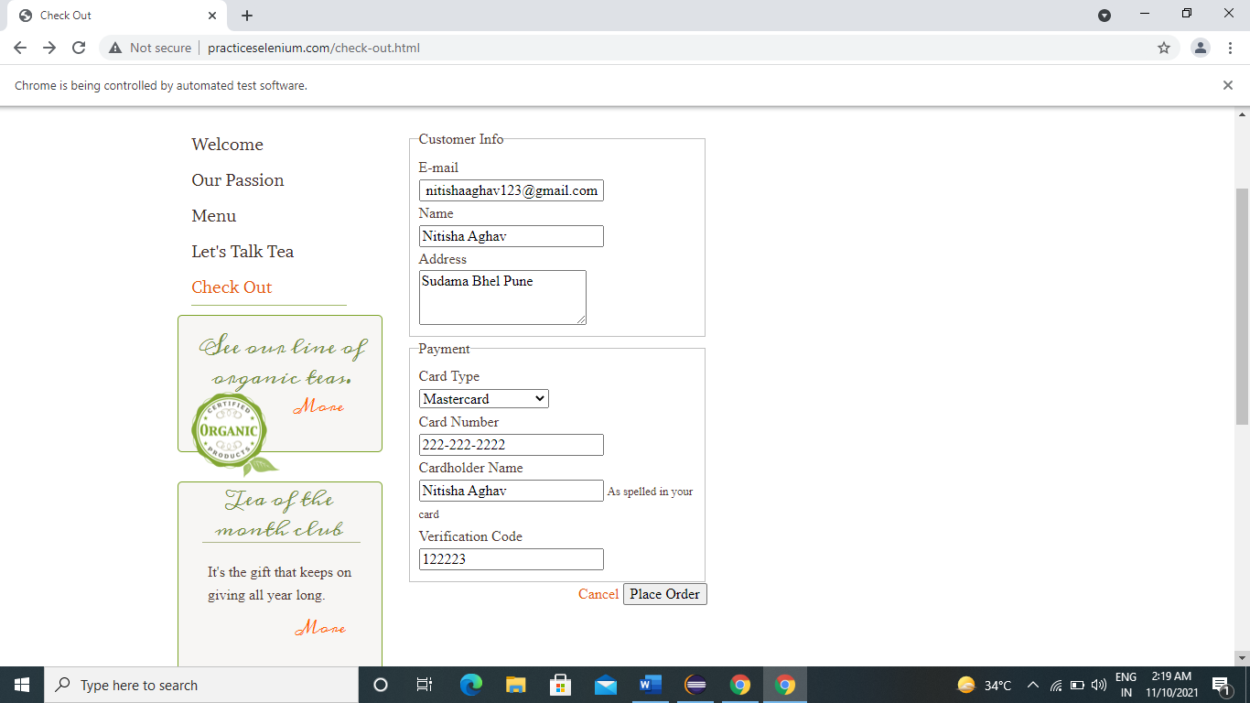

11)w.findElement(By.*linkText*("Check Out")).click();

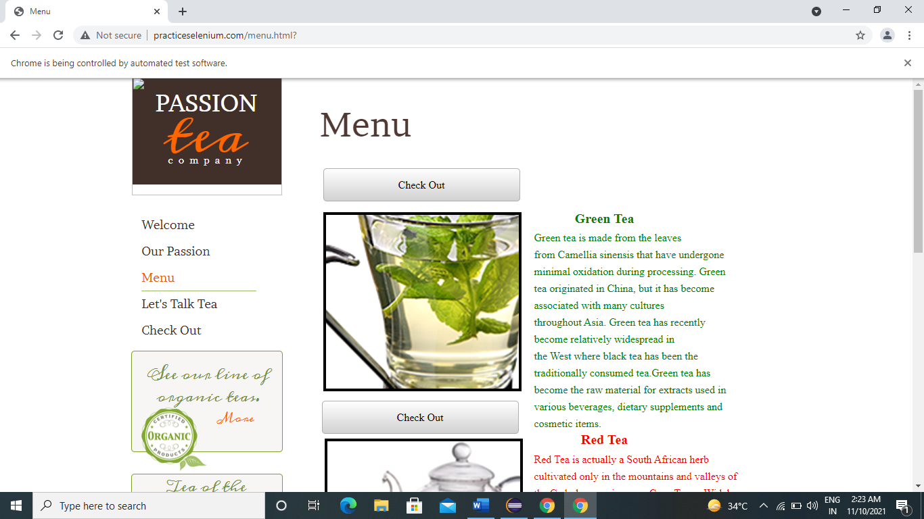

w.findElement(By.id("email")).sendKeys(" [nishaaghav123@gmail.com](mailto:nishaaghav123@gmail.com)");

w.findElement(By.id("name")).sendKeys("Tejas Aghav");

w.findElement(By.id("address")).sendKeys("Rahul Bhel Pune");

Select s1=**new** Select(w.findElement(By.id("card_type")));

s1.selectByVisibleText("Visa");

w.findElement(By.id("card_number")).sendKeys("333-333-333");

w.findElement(By.id("cardholder_name")).sendKeys("nisha Aghav");

w.findElement(By.id("verification_code")).sendKeys("132343");

w.findElement(By.xpath("//*[@id=\"wsb-element-00000000-0000-0000-0000-000452010925\"]/div/div/form/div/button")).click();

Thread.sleep(3000);

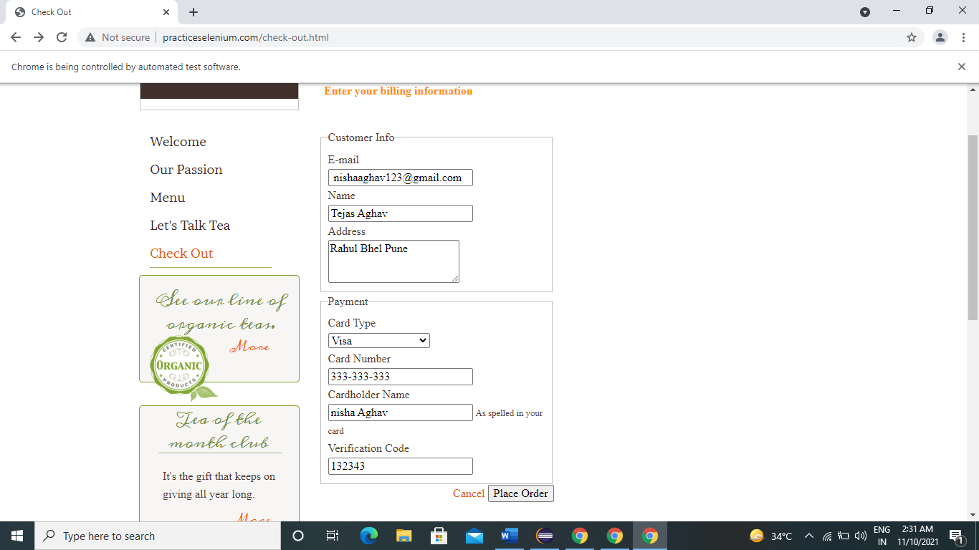

w.findElement(By.*linkText*("More")).click();

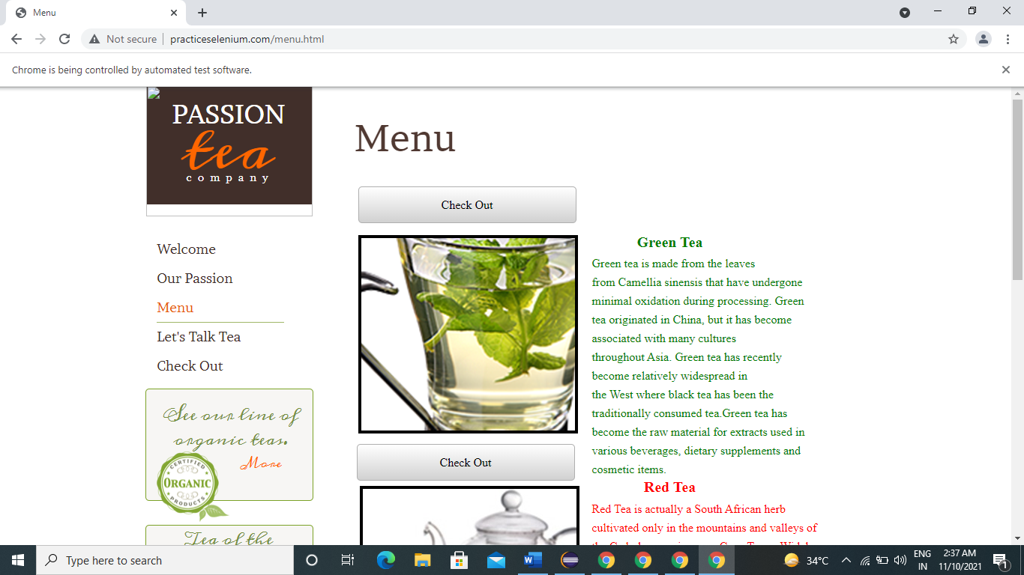

w.findElement(By.*xpath*("//*[@id=\"wsb-element-00000000-0000-0000-0000- 000450914882\"]/div/p/a/span")).click();

**To Test Menu**

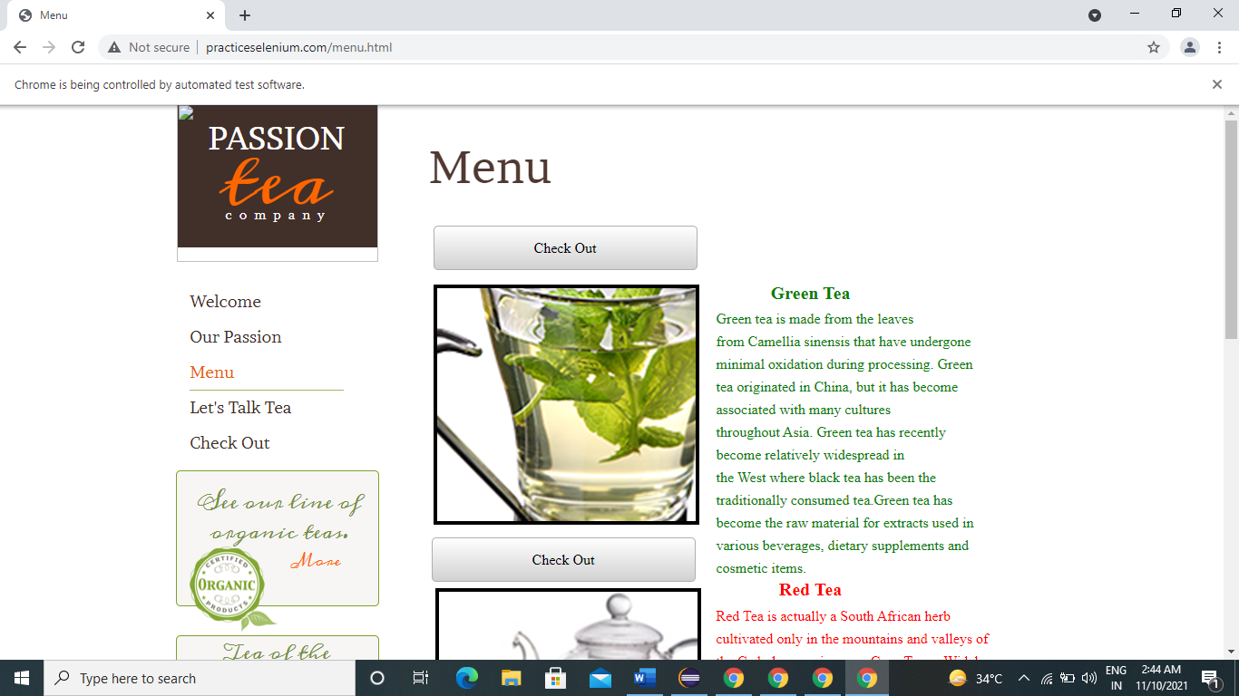

w.get("http://www.practiceselenium.com/");

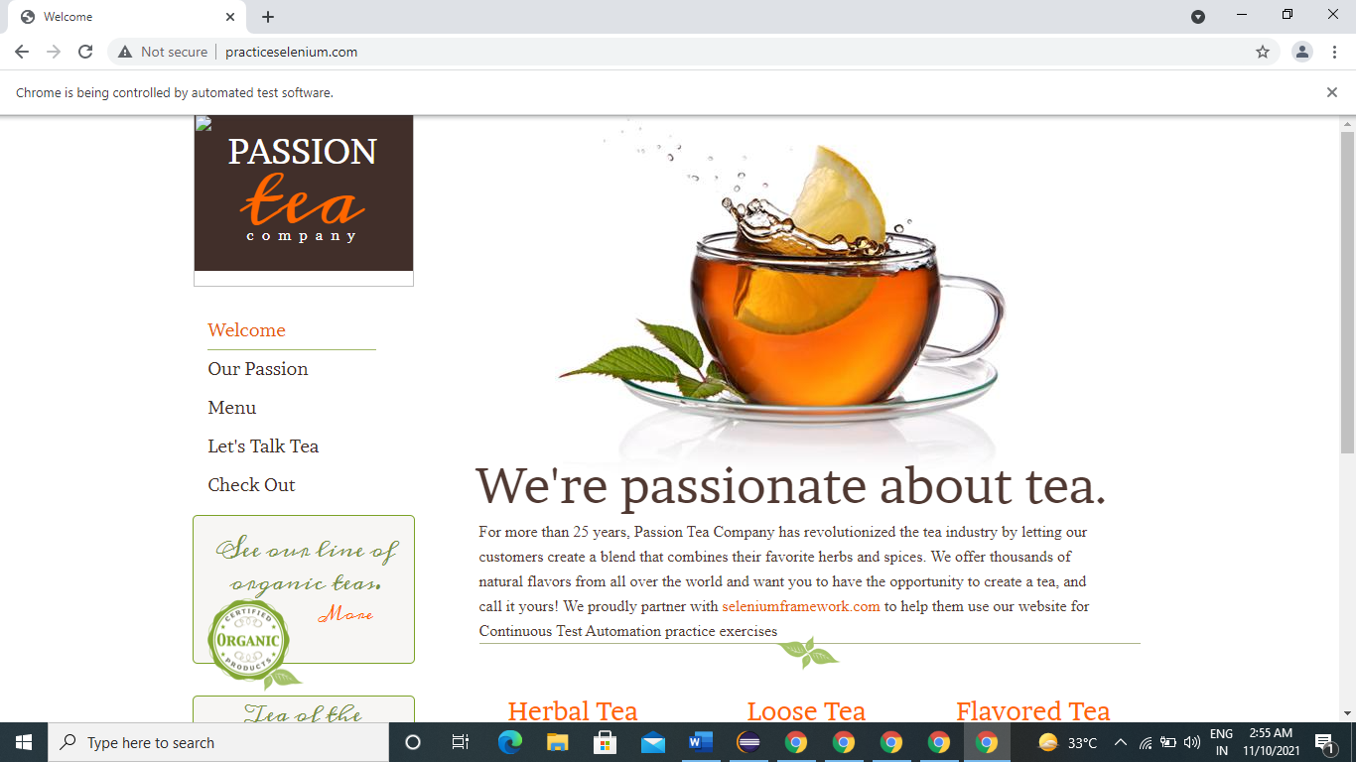

**To Test Selenium Framwork for About**

w.findElement(By.*linkText*("seleniumframework.com")).click();

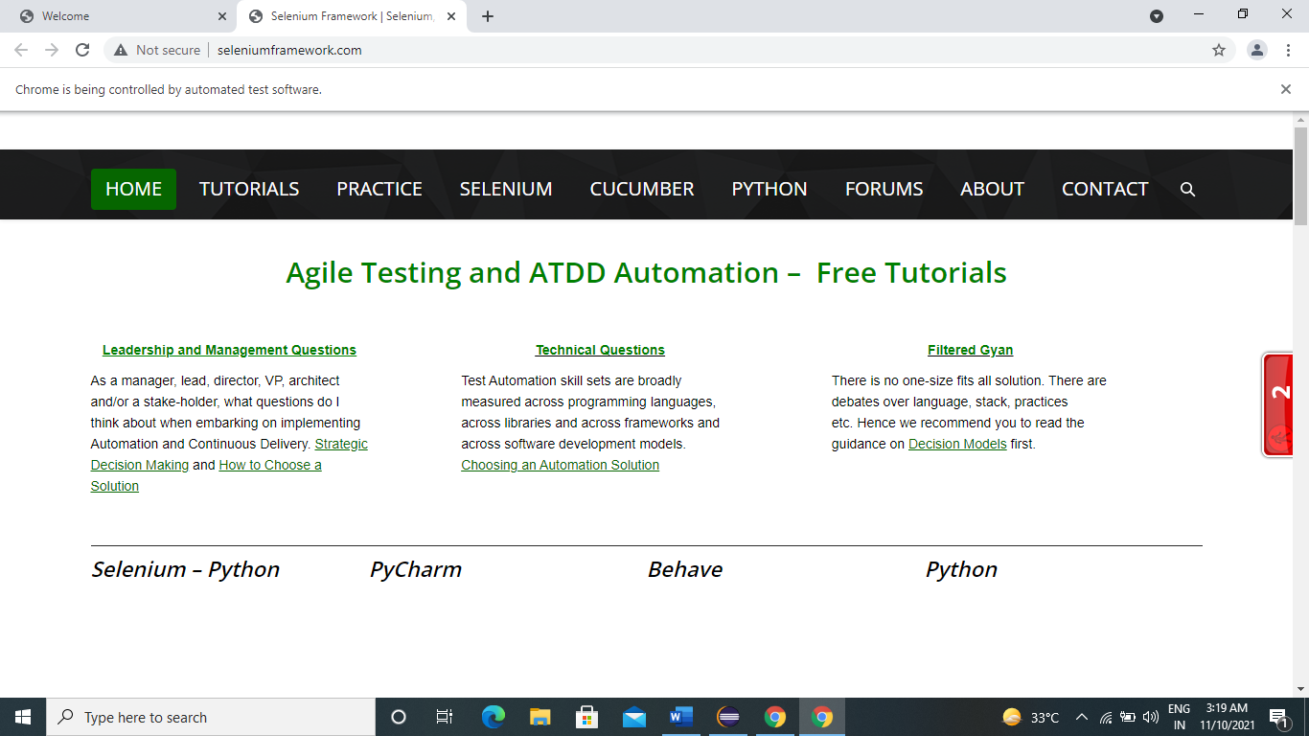

**To Test Other Tabs On Selenium Framework**

w.findElement(By.*linkText*("TUTORIALS")).click();

w.findElement(By.*linkText*("PRACTICE")).click();

w.findElement(By.*linkText*("SELENIUM")).click();

w.findElement(By.*linkText*("CUCUMBER")).click();

w.findElement(By.*xpath*("//*[@id=\"main-nav\"]/li[6]/a/span")).click();

w.findElement(By.*linkText*("ABOUT")).click();

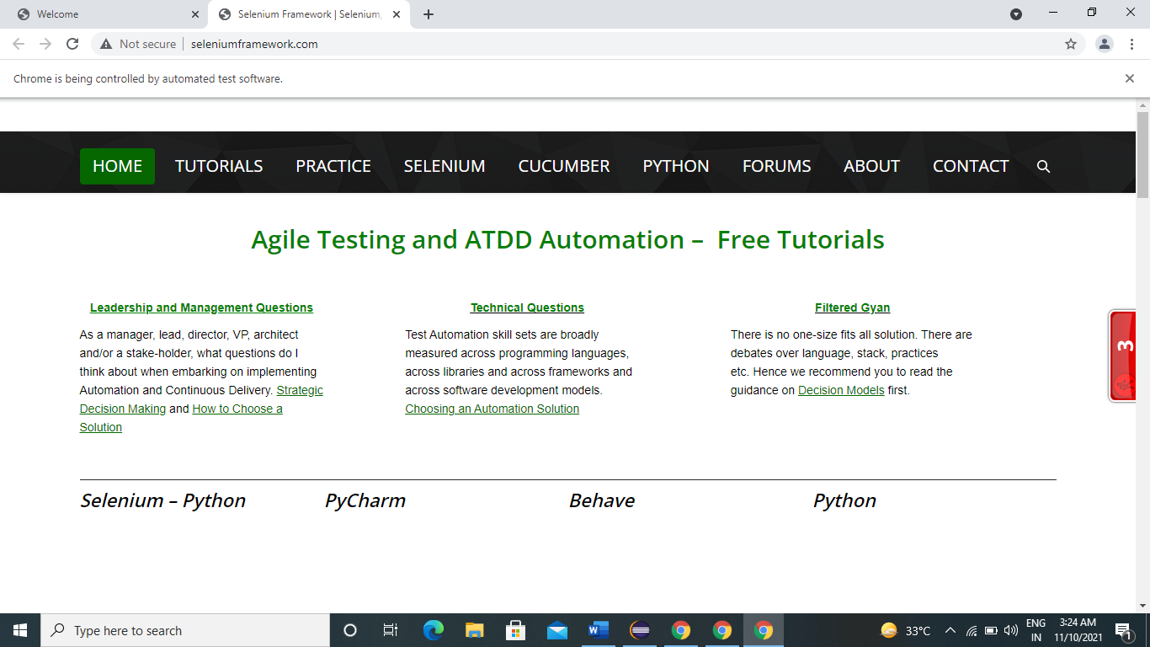

**To Test About**

w.get("http://www.seleniumframework.com/");



w.findElement(By.*linkText*("ABOUT")).click();

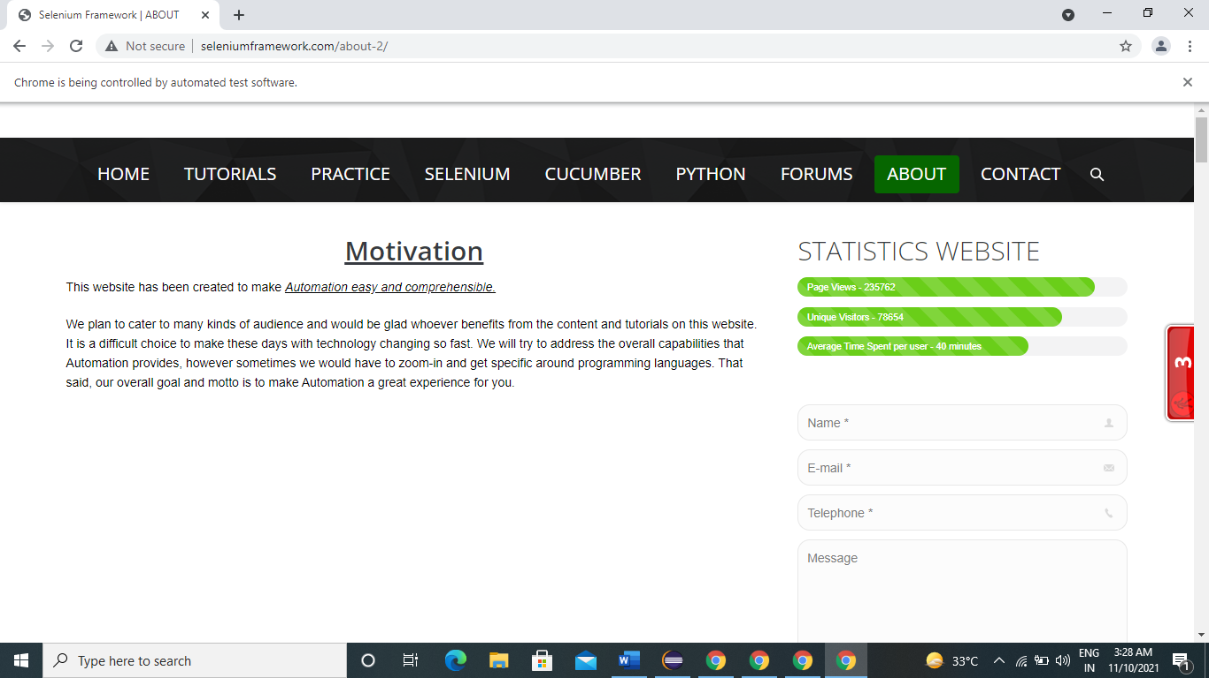

w.findElement(By.*name*("name")).sendKeys("Nisha");

w.findElement(By.*name*("email")).sendKeys("Nisha123@gmail.com");

w.findElement(By.*name*("telephone")).sendKeys("1212121212");

w.findElement(By.*name*("message")).sendKeys("I am fine");

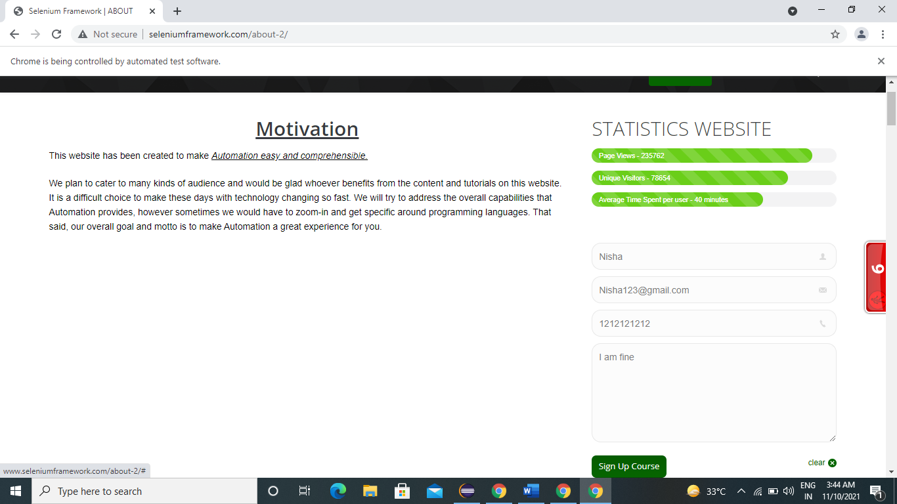

**To Test Sign Up Course**

w.findElement(By.*linkText*("Sign Up Course")).click();

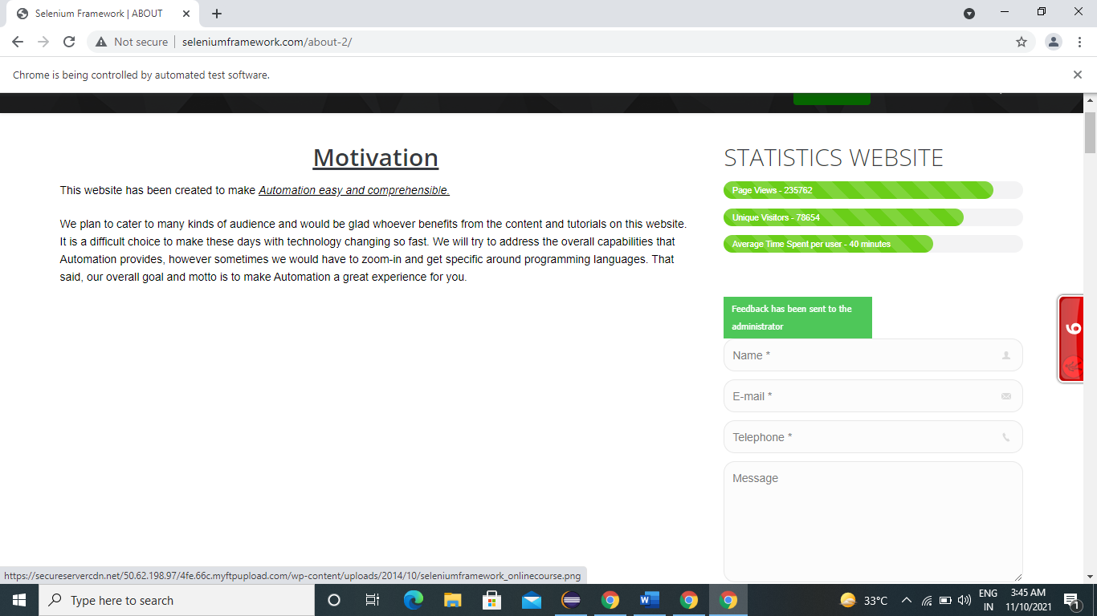

**To Test See Collection for Flavoured Tea**

w.get("http://www.practiceselenium.com");



w.findElement(By.linkText("See Collection")).click();



**To Test See Check Out for Green Tea**

w.findElement(By.*linkText*("See Collection")).click();

//Click On Check Out

w.findElement(By.*linkText*("Check Out")).click();

//Enter Your E-Mail

w.findElement(By.*id*("email")).sendKeys("sonalipawar123@gmail.com");

//Enter Name

w.findElement(By.*id*("name")).sendKeys("Sonali Pawar");

//Enter Adderess1

w.findElement(By.*id*("address")).sendKeys("Solapur");

//Card Type

Select s1=**new** Select(w.findElement(By.*id*("card_type")));

s1.selectByVisibleText("Visa");

//Card Number

w.findElement(By.*id*("card_number")).sendKeys("1234 5678 9012 3456");

//Card Holder Name

w.findElement(By.*id*("cardholder_name")).sendKeys("Sonali Pawar");

//Verification Code

w.findElement(By.*id*("verification_code")).sendKeys("423222");

//Click on Place Oredr1

w.findElement(By.*xpath*("//*[@id=\"wsb-element-00000000-0000-0000-0000-000452010925\"]/div/div/form/div/button")).click();

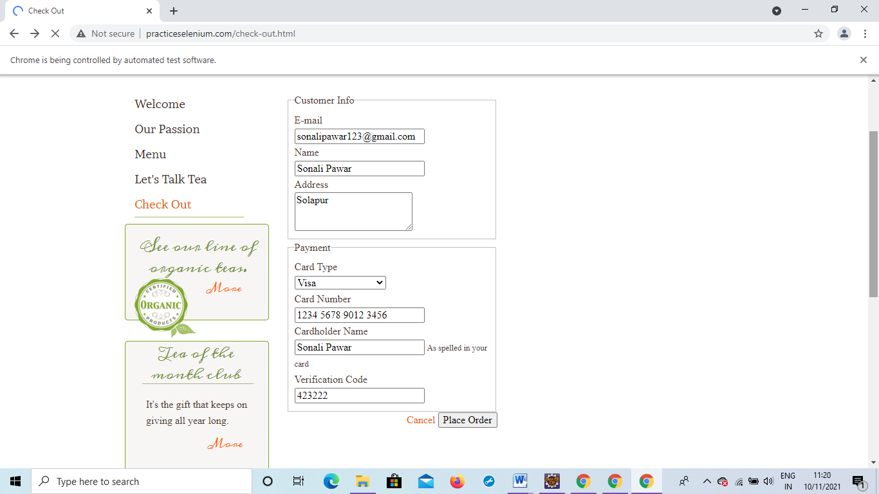

Fig. Output of Check out for Green Tea

**To Test See Check Out for Red Tea**

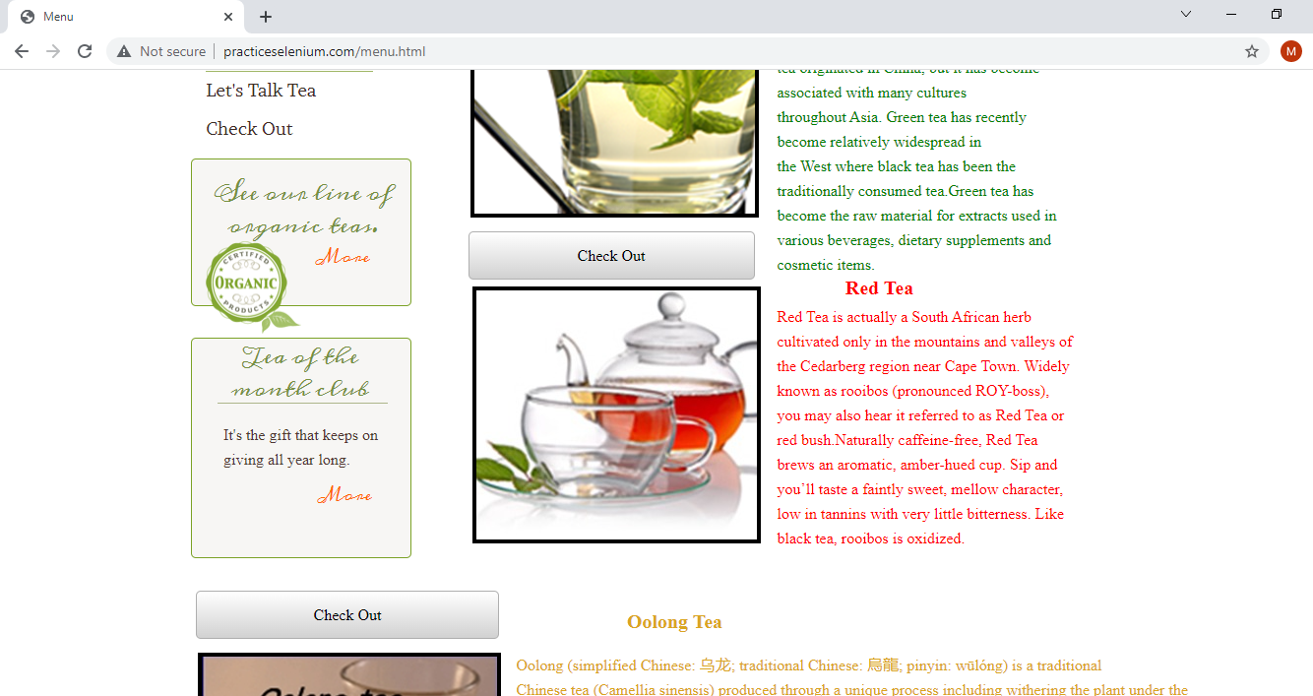

**Fig. check out For Red tea**

//Click On Check Out

w.findElement(By.*xpath*("//*[@id=\"wsb-button-00000000-0000-0000-0000-000451959280\"]/span")).click();

//Enter Your E-Mail w.findElement(By.*id*("email")).sendKeys("manalipawar123@gmail.com");

//Enter Name

w.findElement(By.*id*("name")).sendKeys("Manali Pawar");

//Enter Adderess1

w.findElement(By.*id*("address")).sendKeys("Pune");

//Card Type

Select s2=**new** Select(w.findElement(By.*id*("card_type")));

s2.selectByVisibleText("Mastercard");

//Card Number

w.findElement(By.*id*("card_number")).sendKeys("1987 6543 2112 3456");

//Card Holder Name

w.findElement(By.*id*("cardholder_name")).sendKeys("Manali Pawar");

//Verification Code

w.findElement(By.*id*("verification_code")).sendKeys("456789");

//Click on Place Oredr1

w.findElement(By.*xpath*("//*[@id=\"wsb-element-00000000-0000-0000-0000-000452010925\"]/div/div/form/div/button")).click();

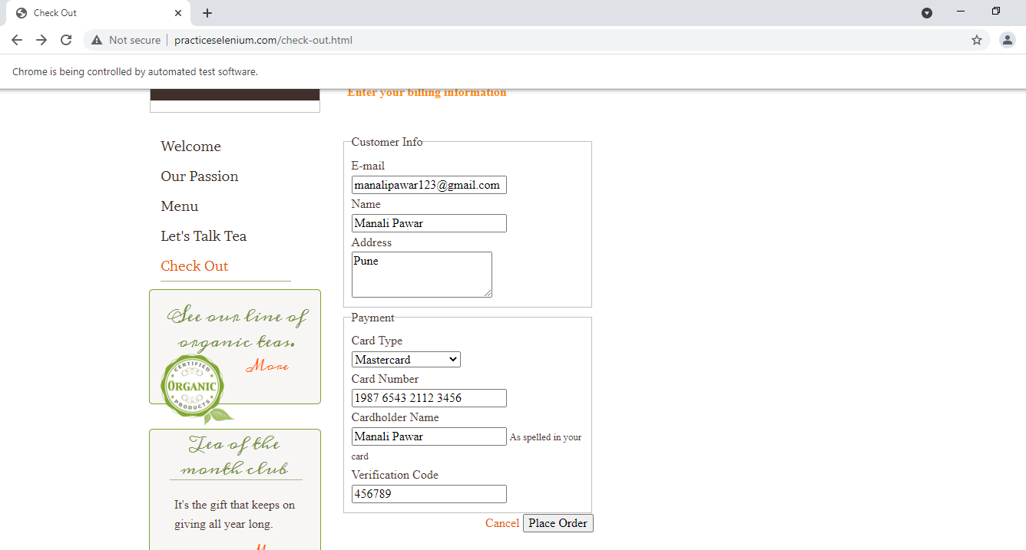

Fig. Output of Check out for Red Tea

**To Test See Check Out for Red Tea**

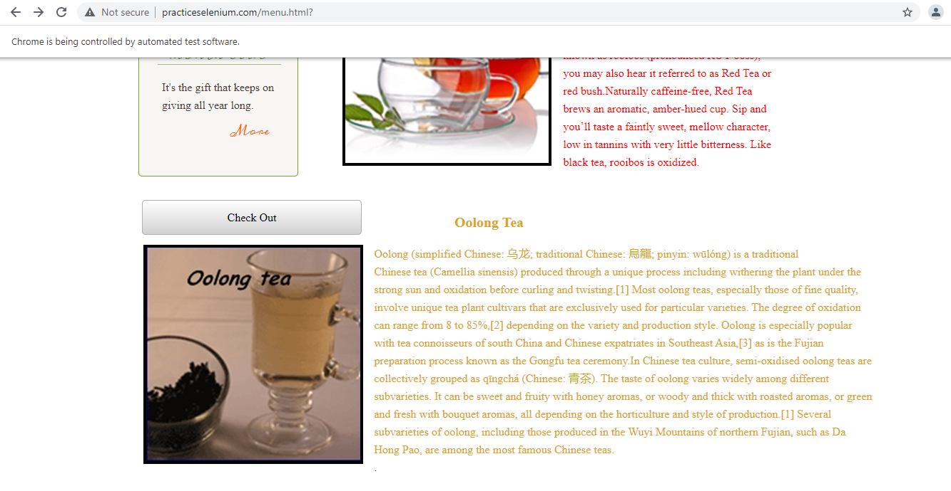

Fig. check out For Oolong tea

//Click On Check Out

w.findElement(By.*xpath*("//*[@id=\"wsb-button-00000000-0000-0000-0000-000451961556\"]/span")).click();

//Enter Your E-Mail

w.findElement(By.*id*("email")).sendKeys("shraddhapawar123@gmail.com");

//Enter Name

w.findElement(By.*id*("name")).sendKeys("Shraddha Pawar");

//Enter Adderess1

w.findElement(By.*id*("address")).sendKeys("Delhi");

//Card Type

Select s3=**new** Select(w.findElement(By.*id*("card_type")));

s3.selectByVisibleText("American Express");

//Card Number

w.findElement(By.*id*("card_number")).sendKeys("1234 0987 4567 1234");

//Card Holder Name

w.findElement(By.*id*("cardholder_name")).sendKeys("Shraddha Pawar");

//Verification Code

w.findElement(By.*id*("verification_code")).sendKeys("533898");

//Click on Place Oredr1

w.findElement(By.*xpath*("//*[@id=\"wsb-element-00000000-0000-0000-0000-000452010925\"]/div/div/form/div/button")).click();

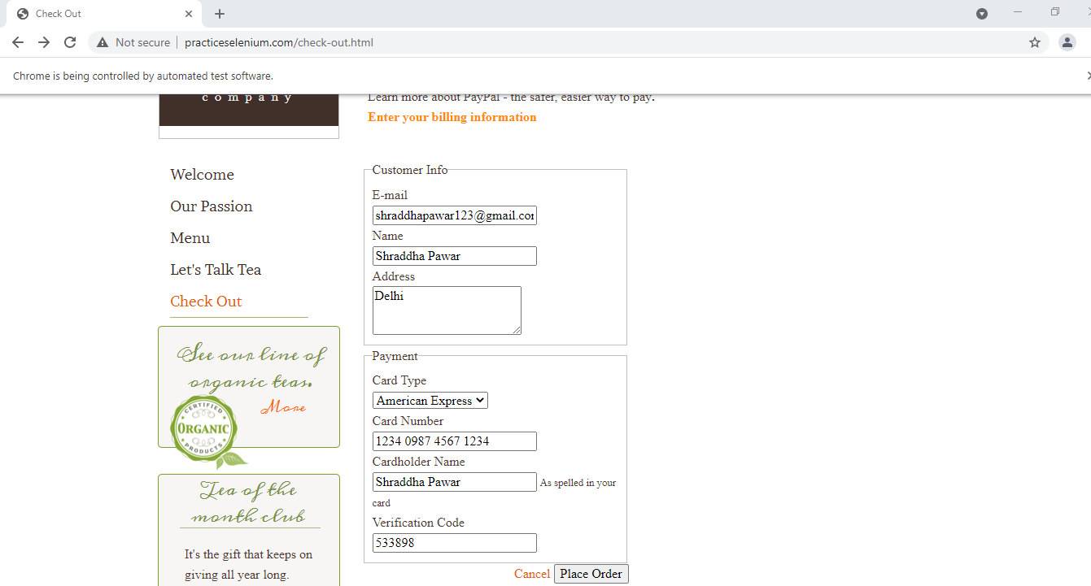

Fig. Output of Check out for Oolong Tea

**To Test Lets Talk Tea**

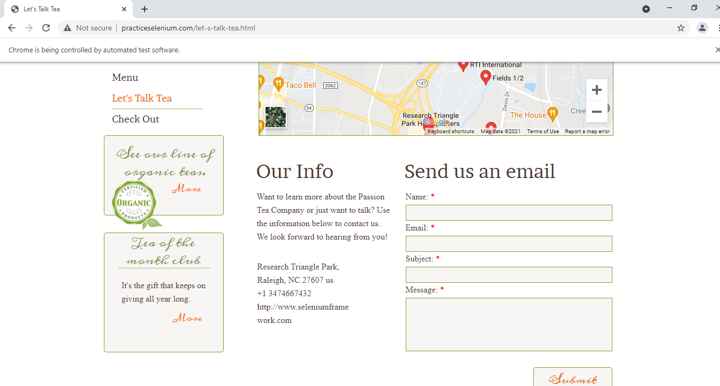

Fig. Let’s Talk Tea

//click on lets Talk Tea

w.findElement(By.*linkText*("Let's Talk Tea")).click();

//Enter Name

w.findElement(By.*name*("name")).sendKeys("Shraddha Kapoor");

//Enter Your E-Mail

w.findElement(By.*name*("email")).sendKeys("shraddhakapoor123@gmail.com");

//Enter Subject

w.findElement(By.*name*("subject")).sendKeys("ABC");

//Enter Message

w.findElement(By.*name*("message")).sendKeys("Hello");

//Click on Submit

w.findElement(By.*xpath*("//*[@id=\"form_78ea690540a24bd8b9dcfbf99e999fea\"]/div[1]/div[5]/input")).click();

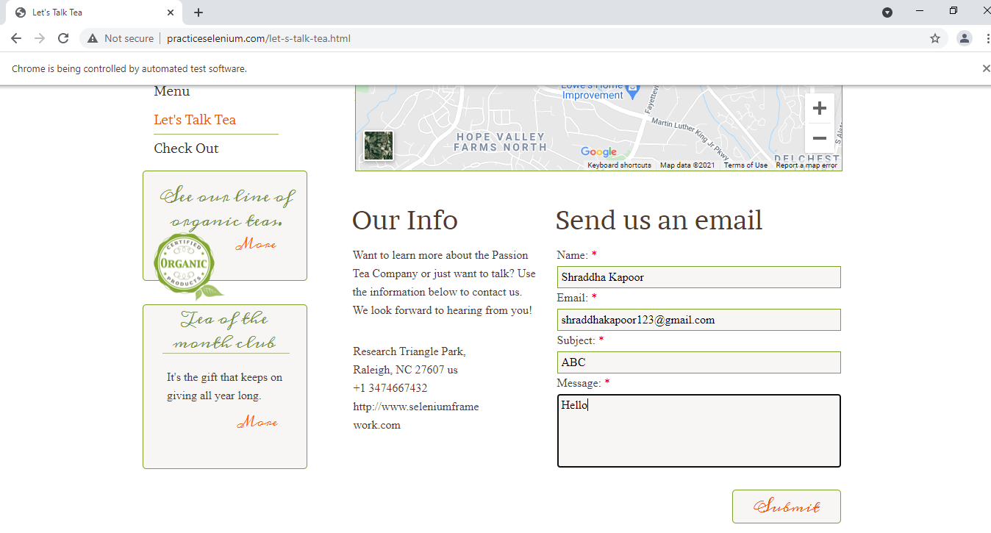

Fig. Output of Let’s Talk Tea

**To Test Contact**

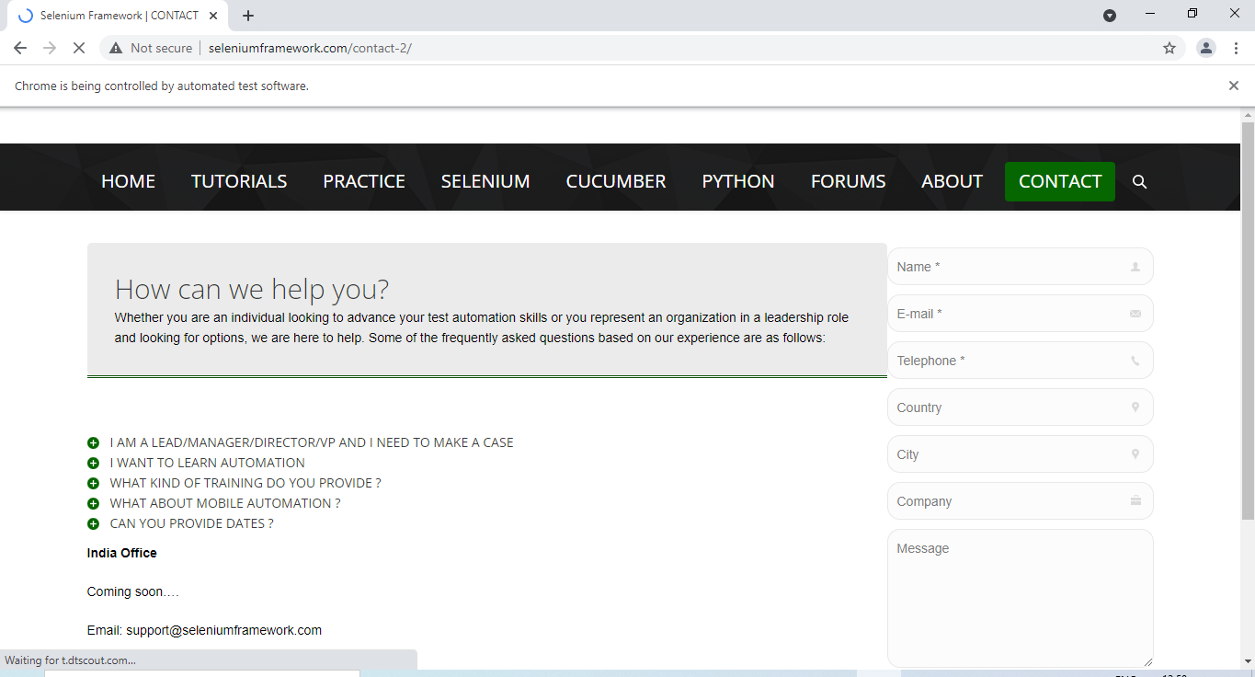

Fig. Fill the contact details

Click on main URL

w.get("http://www.seleniumframework.com/forums/");

//Click on contact

w.findElement(By.*linkText*("CONTACT")).click();

//Enter Name

w.findElement(By.*name*("name")).sendKeys("Sonali Pawar");

//Enter E-Mail

w.findElement(By.*name*("email")).sendKeys("sonalipawar123@gmail.com");

//Enter Telephone

w.findElement(By.*name*("telephone")).sendKeys("012-345-6789");

//Enter Country

w.findElement(By.*name*("country")).sendKeys("India");

//Enter City

w.findElement(By.*name*("city")).sendKeys("Mumbai");

//Enter Company

w.findElement(By.*name*("company")).sendKeys("ABC");

//Enter Message

w.findElement(By.*name*("message")).sendKeys("Details are Successful");

//Click on Send Message

w.findElement(By.*linkText*("Send message")).click();

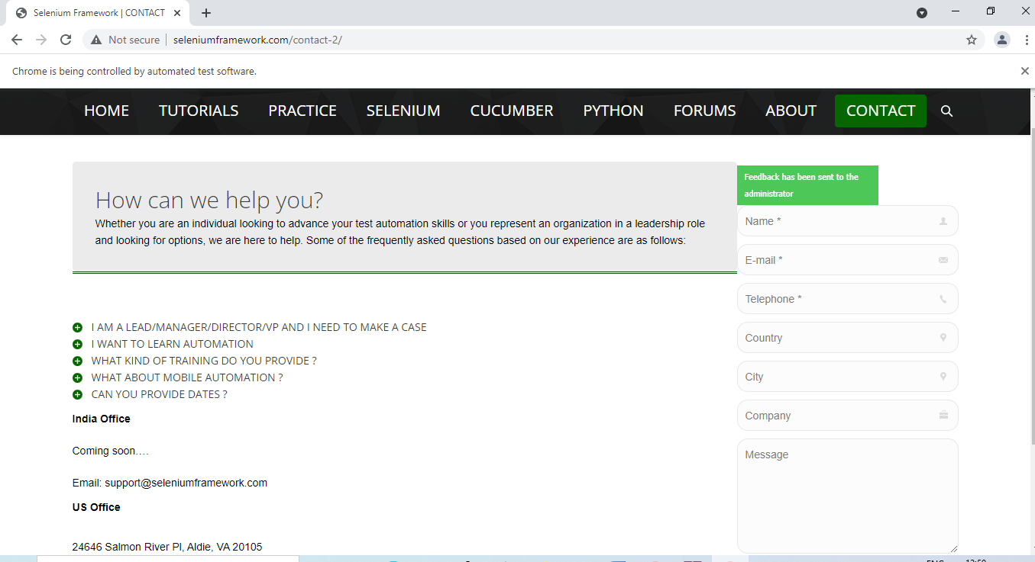

Fig. Output of Contact